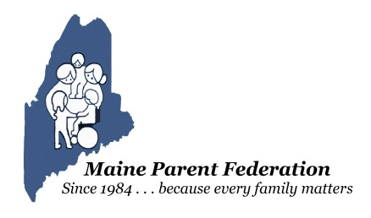
Maine Parent Federation is now offering our trainings Online - Register now!

Transition to Kindergarten - Learn more about transitioning your Pre-schooler to Kindergarten.
This Photo by Unknown Author is licensed under CC BY-SA-NC
Wednesday, April 8th - 3:00 PM - 5:00 PM Register here - https://zoom.us/webinar/register/WN_eu79Hi9KSrCaIWjKfGwewQ

Positive Behavior Supports & Interventions at Home During COVID 19 - Learn behavior strategies you can use while home schooling during COVID 19.
This Photo by Unknown Author is licensed under CC BY-ND
Thursday, April 9th - 3:30 PM - 5:30 PM Register here - https://zoom.us/webinar/register/WN_50vaHwy5RRGzBSq-fikgHA

Transition to Adulthood - Learn information and resources to help your transition age child navigate transitioning to adulthood. Wednesday, April 15th - 3:00 PM - 5:00 PM Register here -https://zoom.us/webinar/register/WN_FO0xaYmhSBmPSUuZZ_QZQg

If you have questions or need more information, please call our office at 800-870-7746 or E-mail parentconnect@mpf.org.

PO Box 2067, Augusta, Maine 04338-2067 ~ Tel: (207) 588-1933, (800) 870-7746 (Statewide)
Fax: (207) 588-1933 ~ E-mail: parentconnect@mpf.org ~ Web: www.mpf.org

