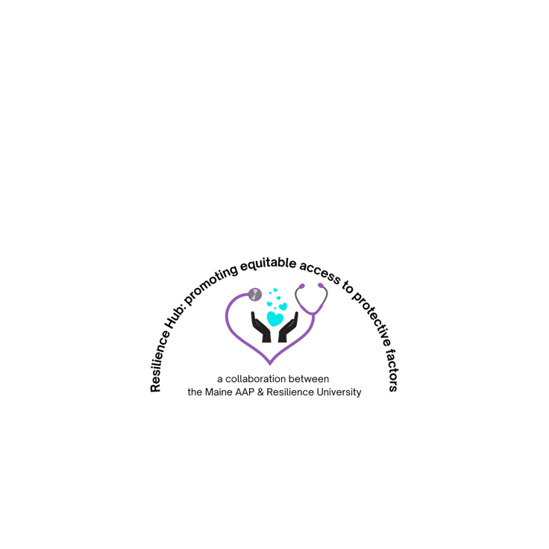

**Resiliency Resources for Parents**

**Parent Support:**

G.E.A.R. Parent Network: family support network for parents whose children have behavioral issues <https://gearparentnetwork.org/>

Child Care Choices: providing families with a searchable database for childcare choices as well as resources about what to look for in a good childcare setting <https://www.childcarechoices.me/>

Maine Autism Society: support and community for families of children with Autism <https://www.asmonline.org/>

Maine Parent Federation: support for families of children with special needs <https://www.mpf.org/>

NAMI Family Support Groups: peer-led support group for any adult with a loved one who has experienced symptoms of a mental health condition <https://www.nami.org/Support-Education/Support-Groups/NAMI-Family-Support-Group>

NEABPD Family Connections Program: based on research funded by the [National Institute of Mental Health](http://www.nimh.nih.gov/). Survey data from previous courses show that after completing the course, family members experience decreased feelings of depression, burden, and grief, and more feelings of empowerment<https://www.borderlinepersonalitydisorder.org/family-connections/>

Maine Crisis: if you or a loved one is experiencing a mental health crisis, you can call 988 or access one of the many options (hotline, warmline, crisis assessment, and more) at <https://namimaine.org/crisis-resources/>

**Parenting Resources:**

Triple P “Positive Parenting Program” highly studied, created by a psychologist in Australia; may be available in your community <https://www.triplep.net/glo-en/home/>

AAP “Special Time:” suggestions on how to implement this for parents <https://downloads.aap.org/AAP/PDF/Family_SpecialTime.pdf>

Resilience Building Ideas for Parents: the Center for the Study of Social Policy put together a website and downloadable PDF guide for parents <https://cssp.org/building-resilience-in-troubled-times-a-guide-for-parents/>

**Parenting Books:**

The Whole Brained Child Dan Siegel & Tina Bryson

Brain-Body Parenting Mona Delahook

**Social Media Resources:**

Sparks video series: videos for each developmental stage to help parents connect with their kids <https://www.sparksvideoseries.com/>

UMass Chan Medical School videos for parents: <https://www.umassmed.edu/cttc/pair-a-docs-video-series/>

@Doctor_Pianka: Founder of Resiliency university and authoring a book on the topic for the national AAP, Maine Pediatrician Dr. Pianka brings tips for resilience to you via Instagram, TikTok, Facebook and YouTube